Marathwada Mitra Mandal’s

College of Engineering

**Department of Electronics & Telecommunication Engineering**

T.E. E&TC, Sem-II, Year 2022 – 23

**Project Group Details & Synopsis of Project Project Group Details**

|  |  |
| --- | --- |
| Group Number:- | **26** |

|  |  |  |  |  |  |
| --- | --- | --- | --- | --- | --- |
| **Sr. No.** | **Roll No.** | **Name of Student** | **Division** | **Mobile No.** | **Signature** |
| 1. | 255 | Advait Thale | TE 2 | 7414952172 |  |
| 2. | 257 | Mansi Veer | TE 2 | 7499407119 |  |
| 3. | 256 | Sameeran Unchegaonkar | TE 2 | 9322257002 |  |
|  |  |  |  |  |  |

|  |  |
| --- | --- |
| **Project Title:-** | Maximum Power Point Tracker with Quasi-Resonant Topology added to Hardware controlled Opto-isolated 240V AC outputs and function driven status display |

|  |  |  |  |  |
| --- | --- | --- | --- | --- |
| **Broad Area:-** (Tick **√** only one) | 1. Communication Engg. |  | 2. Networking |  |
| 3. Embedded / Microcontroller |  | 4. Image Processing |  |
| 5. VLSI |  | 6. Power Electronics | ✓ |
| 7. Instrumentation / Automation Control |  | 8. ANN / Other |  |

1. **INTRODUCTION**

This project includes following 3 points:

1) Maximum Power Point Tracking.

2) Estimation of Load, Battery, and Solar Charging Wattage.

3) Software Controlled Load Outputs

The charge controller looks at the output of the panels and compares it to the battery voltage. It then figures out what is the best power that the panel can put out to charge the battery. It takes this and converts it to best voltage to get maximum AMPS into the battery.

Additional (Automation) Features includes,

* 20 x 4 Character LCD for status and configuration function
* 2 x Software controlled Solid State Load Outputs (up to 40V DC)
* I/O for addition sensors (configurable)
* DIP Switches for Boot configuration & customization
* RS-232 D9 Port for Data Log (at 9600)

**MPPT Prototype (#3):**

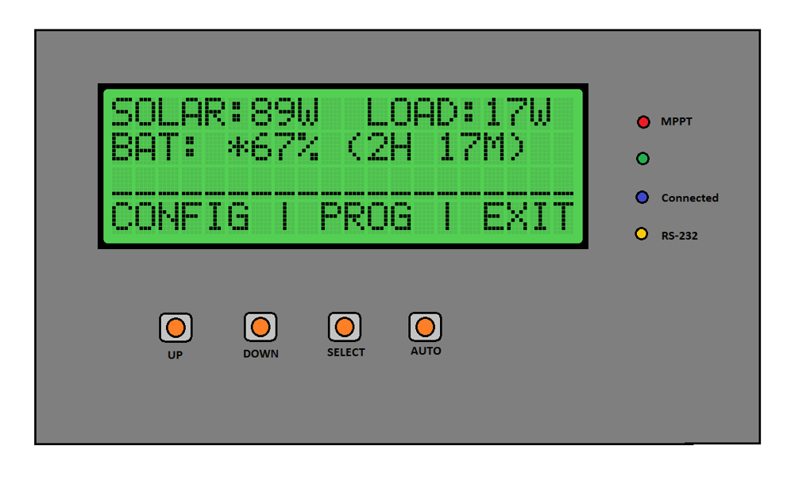

**2. BLOCK DIAGRAM**

**ESP 32**

LED Strip Lght

**MPPT**

**Solar Panel**

(Input)

BLDC Motor

USB Charger

**Battery**

**6 V 4.5 AH**

**3. APPLICATION**

1) Solar charging and Load operation.

2) Controlling Load over Wi-Fi.

3) Basic control similar to Home Automation.

**4. SOFTWARE AND HARDWARE REQUIRED**

# Software :

# 1)Proteus

# Hardware:

# 1) ESP 32

# 2) Input: Photovoltaic Panel

# 3) Load: LED Strip, BLDC Motor, USB Charger

# 

**5. REFERENCES**

1] Paul Horowitz, Winfield Hill, “Power Sources: Battery Types”, in The Art of Electronics, Second Edition, Pg. 920-931.

2] D. P. Kothari, I.J. Nagrath, “Solar Energy & its Utilisation”, in Modern Power System Analysis, Fourth Edition, Pg. 32-42.

3] Paul Horowitz, Winfield Hill, “Solar Cells”, in The Art of Electronics, Second Edition, Pg. 932-933.